Containerization SYST8141  
Assignment-1  
  
Swathi Anil  
8905477

**Task 1: Creating a user, made anil as super user using Vi editor and logged in as super user.**

#Logged in anil as a super user

**Task 2: Creating file name test1 in the home directory of the user (anil)**

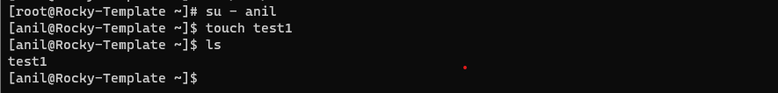

**Task 3: Assigning different file Permissions:**

# Using chmod command granted permissions to Owner, group and other.

**Task 4: Creating docker image from hub.docker.com**

#MongoDB images from hub.docker.com is used

#MongoDB images running on docker

# Images running successfully



**Task 5: Start docker image nginx and start container**

#Ngnix image pulling

#Nginx image running

**Task 6: Check container ID**

# Checked container ID using docker ps command



**Task 7: Stop container**

# Stopped container using the command– docker stop <containerID>

**Task 8: Start container**

# Started container using the command – docker start <containerID>

